Prongs

Problem Notes

Warning: This document is full of spoilers!
Each section is intended to help you get a better understanding of the maths behind the problem. Read only as much as you want, and no more.
Important: It is not intended that you share these explanations with your students.
It’s intended that students come up with their own explanations and their own ideas, with you helping as needed.

Contents:
Playing the game 2
Counting things 2
Putting it together 4
Another approach: smaller games 4
Think Beyond 6

Playing the game
By playing the game a few times, we notice a few things.
First, it seems like Player 2 always wins. If we count the moves we can say more: The game always seems to end after 18 moves (Player 2 takes the 18th move, then Player 1 isn’t able to move and loses).
We also notice that as the game progresses, there are more and more “dead” prongs – a prong by itself in a region, that can’t be connected to anything else.
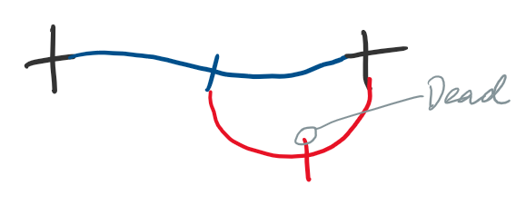
Next, each move connects two prongs, removing them from the game, but then adds two more prongs. So after every move there are still the same number of prongs as there were at the start (16), though some of them may be dead.
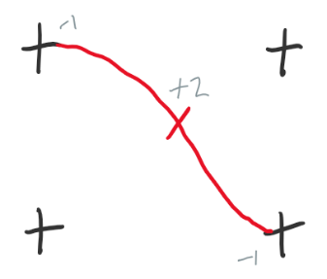
Finally, the game ends when all the prongs are dead. So it seems to take 18 moves to turn 16 live prongs into 16 dead ones. Why should this be?

Counting things
As the game progresses, there are a few numbers we might like to keep track of. We know the number of prongs doesn’t change, but the number of dead prongs does. A dead prong is always in a closed region, but closed regions may have more than one prong, so it might be worth keeping track of them as well.
So here is the finished result of a game (with the moves numbered), along with how the numbers of dead prongs and regions changed during the game:
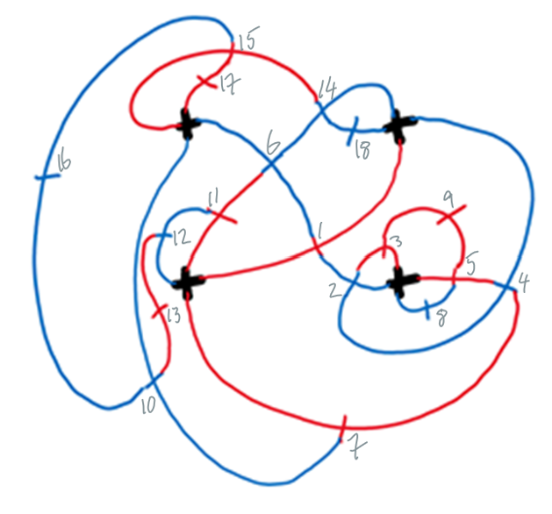
Turn | 0 | 1 | 2 | 3 | 4 | 5 | 6 | 7 | 8 | 9 | 10 | 11 | 12 | 13 | 14 | 15 | 16 | 17 | 18
Dead prongs | 0 | 0 | 0 | 1 | 1 | 1 | 1 | 2 | 4 | 6 | 6 | 7 | 8 | 10 | 10 | 10 | 12 | 14 | 16
Regions | 0 | 0 | 0 | 1 | 2 | 3 | 3 | 4 | 5 | 6 | 7 | 8 | 9 | 10 | 11 | 12 | 13 | 14 | 15

Now we can observe a few more things:
First, at the end of the game there is one more dead prong than there are regions. We have one dead prong in each region, except for one extra dead prong that is poking outside of the clump. (We could also count the external area as an extra region, meaning there would be exactly one dead prong per region. This is often done in Graph Theory.)
Second, a move can increase the number of dead prongs by 0, 1 or 2. At the moment we’re not sure what to do with this observation.
Third, most moves increase the number of regions by 1, but some increase it by 0. In fact, any time two prongs are joined that are on the same connected piece – the same clump of lines – one new region is created:
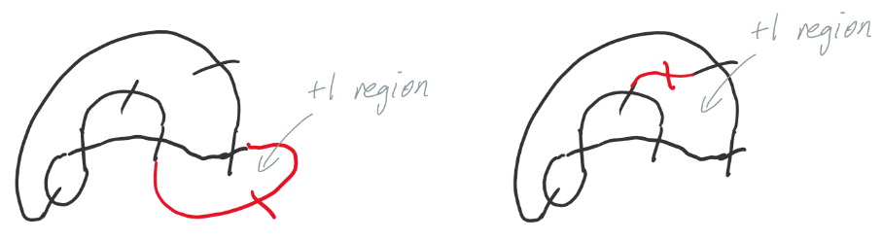
- Can you find a way to be sure that exactly one new region is created in this case?
The only other option is that two prongs are joined that are on different connected pieces, in which case no new region is created:
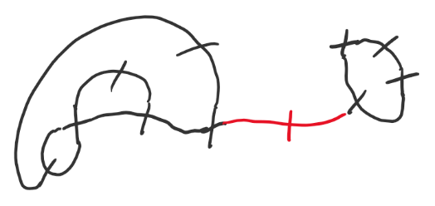
We can think of these as two different types of moves:
- Joining 2 prongs on the same piece: $R→R+1$
- Joining 2 prongs on different pieces: $R→R$
Where $R$ is the number of regions.
- Can you find a way to be sure that these are the only two possible moves?
Actually, type B will decrease the number of pieces by 1 (since it joins two of them), and type A doesn’t change it. If we call $P$ the number of connected pieces, then the two moves are:
- Joining 2 prongs on the same piece: $R→R+1$ $P→P$
- Joining 2 prongs on different pieces: $R→R$ $P→P-1$
So every turn, either the number of regions goes up by one, or the number of pieces goes down by one. Let’s check that table again:
Turn | 0 | 1 | 2 | 3 | 4 | 5 | 6 | 7 | 8 | 9 | 10 | 11 | 12 | 13 | 14 | 15 | 16 | 17 | 18
Dead prongs | 0 | 0 | 0 | 1 | 1 | 1 | 1 | 2 | 4 | 6 | 6 | 7 | 8 | 10 | 10 | 10 | 12 | 14 | 16
Regions | 0 | 0 | 0 | 1 | 2 | 3 | 3 | 4 | 5 | 6 | 7 | 8 | 9 | 10 | 11 | 12 | 13 | 14 | 15
Pieces | 4 | 3 | 2 | 2 | 2 | 2 | 1 | 1 | 1 | 1 | 1 | 1 | 1 | 1 | 1 | 1 | 1 | 1 | 1
This matches with our data!

Putting it together
We started with 4 pieces and ended with 1, so we needed to do 3 type B moves.
We started with 0 regions and ended with 15 (one per dead prong, minus one), so we needed to do 15 type A moves.
And we argued that these are the only two possible types of moves. So in total we have 3+15 = 18 moves.

More generally, in a game with $P$ pieces and $N$ prongs, there will be $P-1$ type B moves and $N-1$ type A moves, for a total of $P+N-2$ moves.

Another approach: smaller games
Our game had four pieces with four prongs each. We could play on each separate piece first, and only join them together at the end. A game played this way might finish looking like this (where the red moves were performed last):
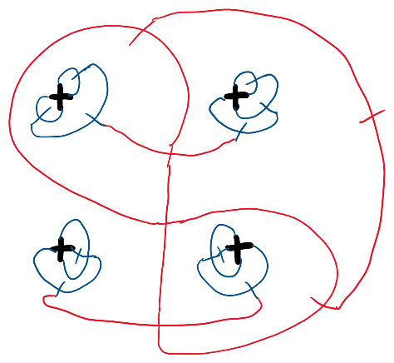
Each of the four pieces becomes its own mini-game. We can work out what goes on in the mini-games and then figure out how to connect them together.
It looks like each mini-game takes 3 moves. In fact there are only three ways to play the mini-game, which are all represented in the above picture.
It looks like joining all the mini-games together takes 6 moves (making a total of 3*4+6=18). But this is a little bit harder to understand – why 6?
Instead of joining all four mini-games together, let’s say we have two mini-games and see how many moves it takes to join those:
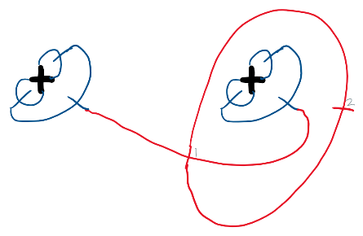

Ah, 2! This is a bit easier to understand. The first move joins the two available prongs on the two mini-games, and the second move creates a new region and therefore kills both prongs.

So the first mini-game gives us 3 moves, and as we add each new mini-game, we’re adding 3 moves for the mini-game plus 2 joining moves:
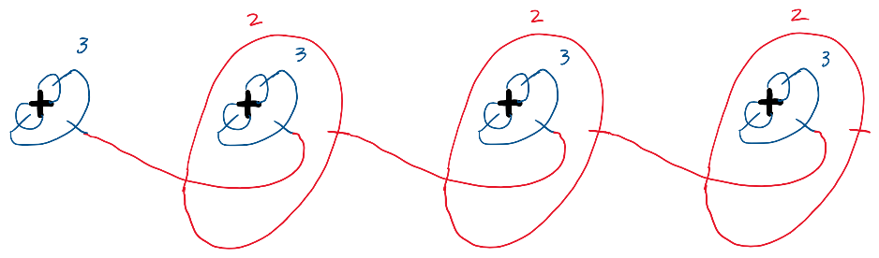
So the total number of moves is 3+5+5+5=18.

Think Beyond
- This game had 4 sets of 4 prongs. What about 3 sets of 3 prongs? What about 5 sets of 7 prongs?

- What if different sets had different numbers of prongs? Say a set of 3, a set of 4, and a set of 6?
- This game had 2 prongs added to each new line. What if it was a different number, say 1?
- In this game the 2 prongs were added one to each side of the line. What if the players could choose where the prongs are added?
Warning: Here be dragons.
There is a closely related game called Sprouts, invented by John Conway and Michael Paterson.
Instead of starting with sets of prongs, start with some number of spots. Lines are drawn “sprouting” between two existing spots, and each new line has a new spot drawn on the middle:
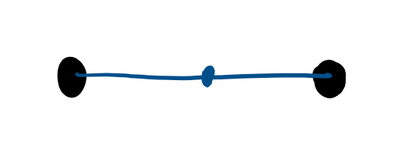
No spot can have more than 3 lines coming from it (so the spot in the middle only has room for one more line!)
Players take turns, and whoever can’t make a move loses.
This game has not been “solved” in general. While it’s known which player has a winning strategy for games starting with up to 44 spots, for any number of spots it is still an open question.

See the MathsCraft Philosophy document, section: “Observations”.
See the MathsCraft Philosophy document, section: “Observations”.
See the MathsCraft Philosophy document, section: “Think before - Think within - Think beyond”.

